Videos to Watch in Class

Video 1
https://www.youtube.com/watch?v=gAZsiZIEeLA&feature=youtu.be

Video 2
https://www.mheducation.com/highered/support/aleks/beyond.html
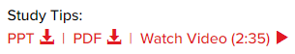

Video 3
https://www.mheducation.com/highered/support/aleks/beyond.html

Video 4
https://www.mheducation.com/highered/support/aleks/beyond.html
